THEME
1 v 1 Finishing Under Pressure

DESCRIPTION OF PRACTICE (TECHNIQUE / SKILL)
A functional practice designed to improve players 1 v 1 ability in finishing with transition to defend

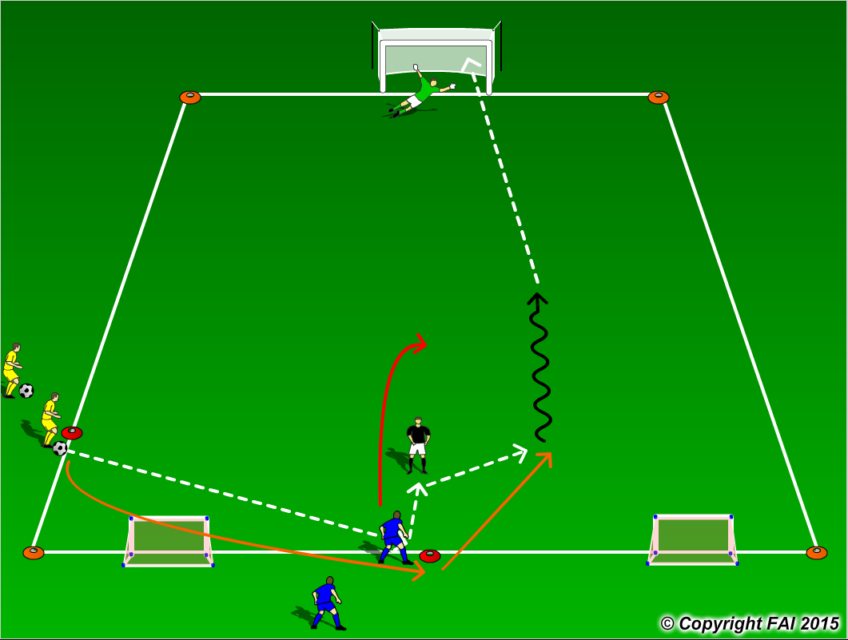

ORGANISATION
- Area 20 x 15 metres
- 1 Yellow (attacker) v 1 Blue (defender) + 1 GK with Coach acting as server
- Game starts as follows:
1 – Yellow player passes to Blue player, after the pass makes a run around the Blue player
2 – Blue player then passes to Coach, and then makes a run around the coach
3 – Coach passes to Yellow who then must attempt to score
- If Blue player wins the ball, he/she attempts to score in either one of the small goals with the Yellow player now transitioning to defend
- Make sure there is a supply of footballs to keep the practice continually flowing

KEY FACTORS
- Quick awareness, control and movement
- Can player receiving the ball use feints or disguises to gain an extra yard or two on defender?
- Good first touch and quick acceleration while dribbling
- Finishing – accuracy over power
- Transition to Defend quickly but under control

NOTES
Make sure that players play till goal is scored, i.e. goal is scored or ball goes out of play and are aware of the transitions. If players of good quality give them time limit to score

