THEME
Small Sided Game 3 v 3 Killer Pass

DESCRIPTION OF PRACTICE (TECHNIQUE / SKILL)
A Practice designed to improve player’s technique, decision making and passing

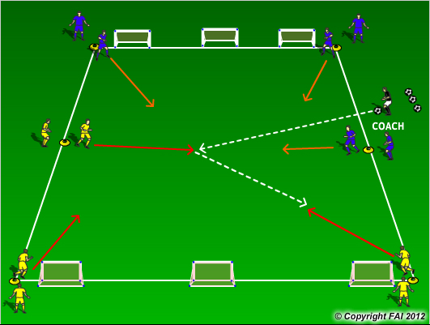

ORGANISATION
- Area 20 x 30 metres
- Player positioned at 3 stations – Middle of the pitch and at each corner, 1 player come out from each station at a time, to create 3 v 3
- Each team has 3 small goals to score in and is encouraged to make killer pass into goals when opportunity arises
- Game continues until goal is scored or ball goes out of play. Players return to their station and go to the back of the group.

KEY FACTORS
- Quick reactions from standing position
- When in possession, create space and a team….angles and distance of support
- Be Positive attack the opposition as quickly to create scoring opportunities (Killer Pass)
- If possession is lost transition to defend…can we win the ball back

NOTES
High tempo activity, supply of footballs beside the coach. Rotate groups so everyone plays in the middle.

