THEME
6 v 3 + 1 Possession with transition

DESCRIPTION OF PRACTICE (TECHNIQUE / SKILL)
A functional practice designed to improve players passing, positioning and decision making with transition
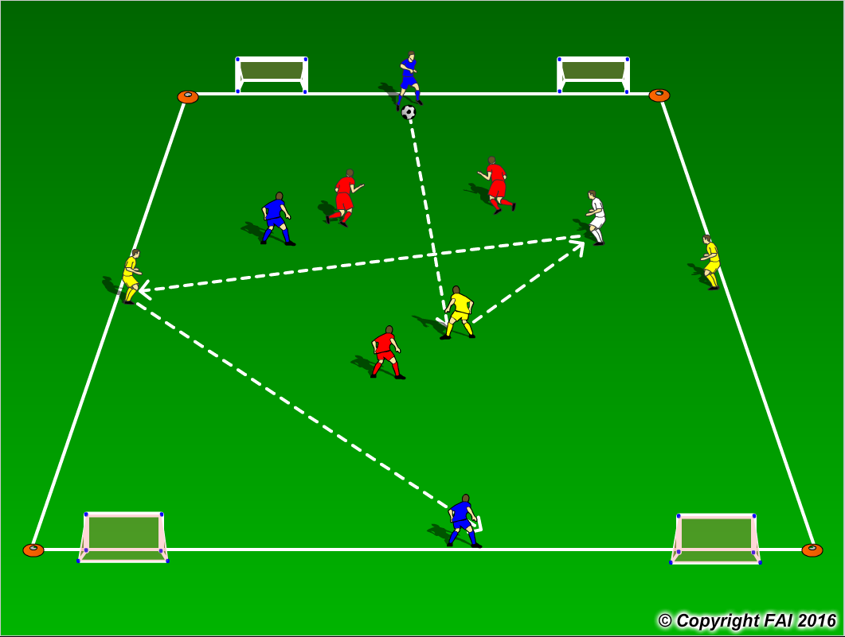

ORGANISATION
- Area: 20 x 20 metres
- 3 Blues & 3 Yellows v 3 Reds + 1 White (neutral). 2 Blue players play at either end of the grid (depth), and 2 Yellow players play either side of the grid (width), with both 1 Blue player and 1 Yellow player in the middle of the grid as seen above. White player to start in the middle to create 3 v 3 situations but has freedom to move within the area and is with team in possession.
- Red players can free foam to attempt to gain possession of the ball.
- If the Red players win the ball, they can score into any of the 4 goals, Blue and Yellow players must now transition to defend and try and win the ball back as quickly as possible.
- Have a supply of footballs to keep the practice continually flowing with a high tempo

KEY FACTORS
- Quality and selection of pass
- Body shape/First Touch/Back Foot
- Disguise/Change of Direction/Rotation among middle players
- Angles and Distance of support – positional play
- Width and depth – Penetrating Pass
- Awareness of space and defender
- Communication between players
- Transition to Defend – can we win ball back as quickly as possible

NOTES
Encourage creativity when closed down to find space, Feints/Tricks/Disguise. Encourage players to play one/two touch football if possible – the ball must constantly be rotating.

