THEME
Passing Warm up - Rondo

DESCRIPTION OF PRACTICE (TECHNIQUE / SKILL)
A Practice designed to warm up players and improve technical skills and focus for session ahead

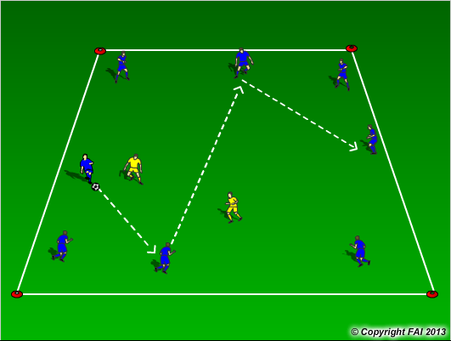

ORGANISATION
- Area: 10 x 10 metres
- 8v2, 7v2, 6v2, 5v2
- Two players in the middle can hold bibs in their hands.
- When defender wins the ball or ball goes outside the area, the player that made the mistake and the player that passed to him switches with the defenders in the middle or the player that made the mistake switches with the defender that has been in the middle the longest
- Play 1 or 2 touch, depending on quality of players

KEY FACTORS
- Quality of pass – pace, weight and accuracy
- Individual movement to receive pass, open body shape
- Individual skills to get out of tight spaces
- Decision making

NOTES
Make sure players play with area.

