THEME
Speed development – Speed and finishing 1v1

DESCRIPTION OF PRACTICE (TECHNIQUE / SKILL)
A practice designed to improve players speed and finishing under pressure

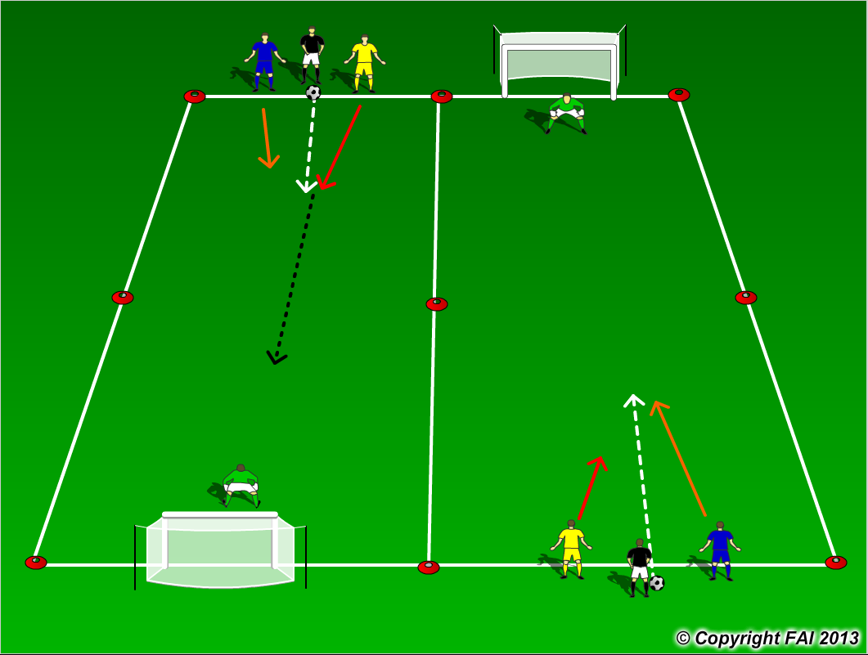

ORGANISATION
- Area: 2 areas of 30 x 15 metres
- Divide players into 2 groups, Goalkeepers in each goal
- Players look straight ahead and react to ball being played in between them by coach
- Players play 1v1 until one scores or the ball goes out of play
- After game is finished players rotate to the other group
- Max 5 per line

KEY FACTORS
- Straight line run – technique of running – head straight, arms close to body, shoulders relaxed, balls of foot touches the ground
- Standing start – watch that players have forward lean and don’t put their foot backwards first
- Acceleration and Deceleration – both equally important
- Change of direction – turn quickly in small space, quick feet
- 100% effort
- Quality of finish
- 1.5 work rest ratio

NOTES
Play for 10-12 minutes max, quality rather than quantity

